## **Introduction**

We are going to rebuild our Assignment 1 but **use Interface Builder** instead of doing it programmatically. Start a New Single View Application !

### **Finished Project**



### **Notes**

* The purpleBox is 50 points tall and positioned 20 points away from the bottom and right edges of the greenView. You can see the purpleBox changes width, but as one point of reference: when the greenView is 500 points wide, the purpleBox is 305 points wide.
* The orangeBoxes are 30 points tall, with the left one being 70 points wide and the right one being 50 points wide.
* The redBox is positioned with its edges 20 points away from the top and right edges of the greenView.
* The blueBoxes are 50 points tall by 50 points wide.
* Everything else is the default spacing between views, either as sibling or parent views.

First, set the view's backgroundColor to green. Next, Let’s do the purpleBox.

You can pin the purpleBox to the greenView's right and bottom edge. You can also fix purpleBox's height. see below screenshot.

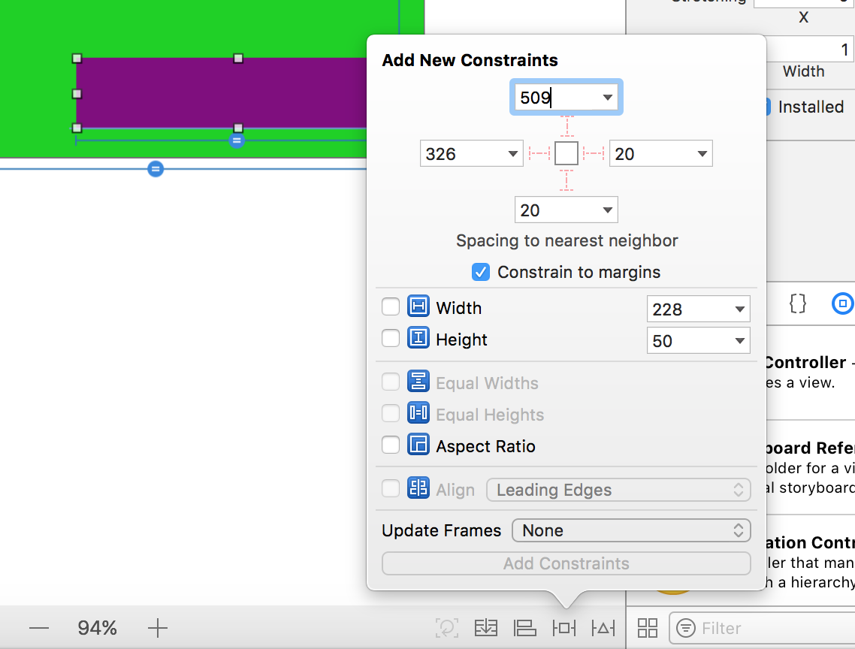

To get purpleBox's width to be a multiplier of the greenView's width. Click on your purpleBox, Press ‘control’ and then drag into the greenView. Create an Equal Widths constraint. In the attributes inspector you can change the multiplier value.

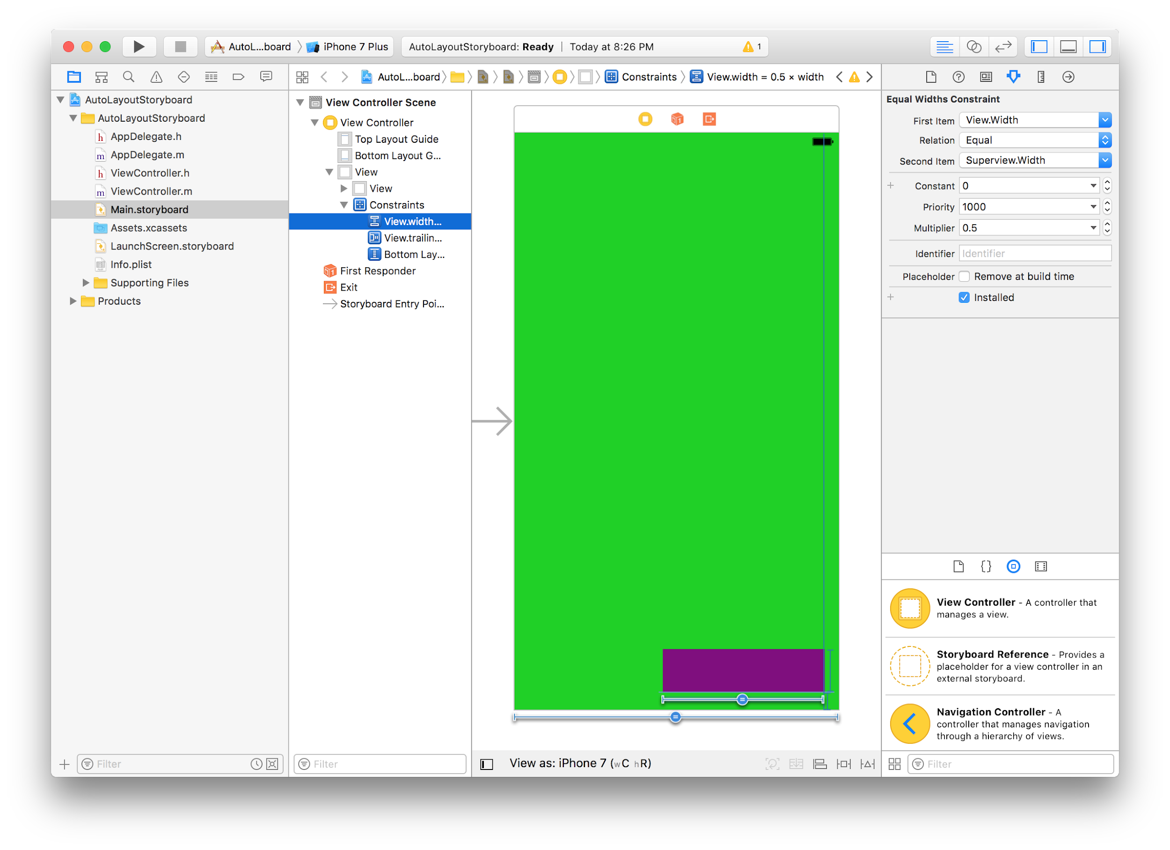

Note: We don't have to run the simulator every time we want to test our layout in landscape. Select View as iPhone ... in the bottom left of the storyboard. This will bring up a new panel where you can select different devices and sizes to view.

